Email Copy

Subject: Have you gotten your COVID-19 vaccine yet?

Body Copy:

Everyone age 5 and older can now receive a COVID-19 vaccine free of charge.

Getting vaccinated is important not only for your own protection, but to protect your loved ones and our community.

The vaccines are safe and effective at preventing serious illness from COVID-19. If you or your loved ones have yet to be vaccinated, schedule an appointment ASAP.

Here’s how:
- Visit scdhec.gov/vaxlocator to find locations accepting appointments.
- Need support? Call DHEC's Vaccine Information Line at 1-866-365-8110 for help.

Vaccines are one of the tools we can use, in addition to wearing a mask, staying six feet apart, and washing our hands, to bring this pandemic to an end. According to CDC guidelines, here’s what you can safely do once you’ve been fully vaccinated.

Already vaccinated? While COVID vaccines are effective, their protection may decrease over time and as new variants emerge. If you’re 16+, see if you’re eligible for a booster shot.

Please help get the word out by sharing this information and/or one of the graphics below.

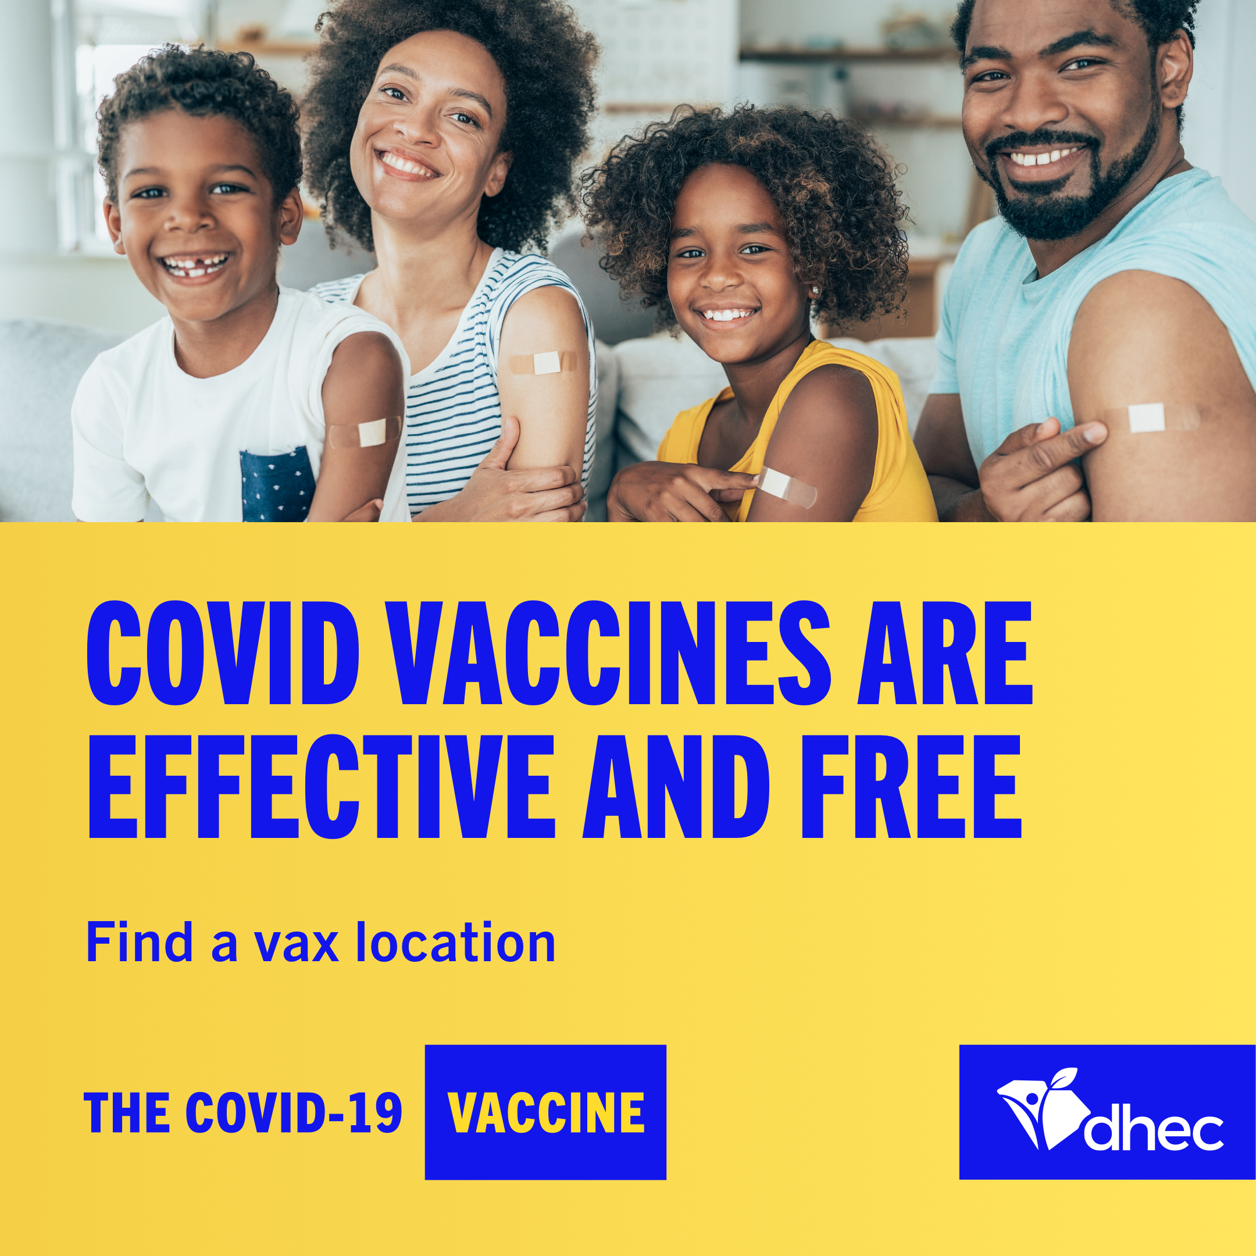

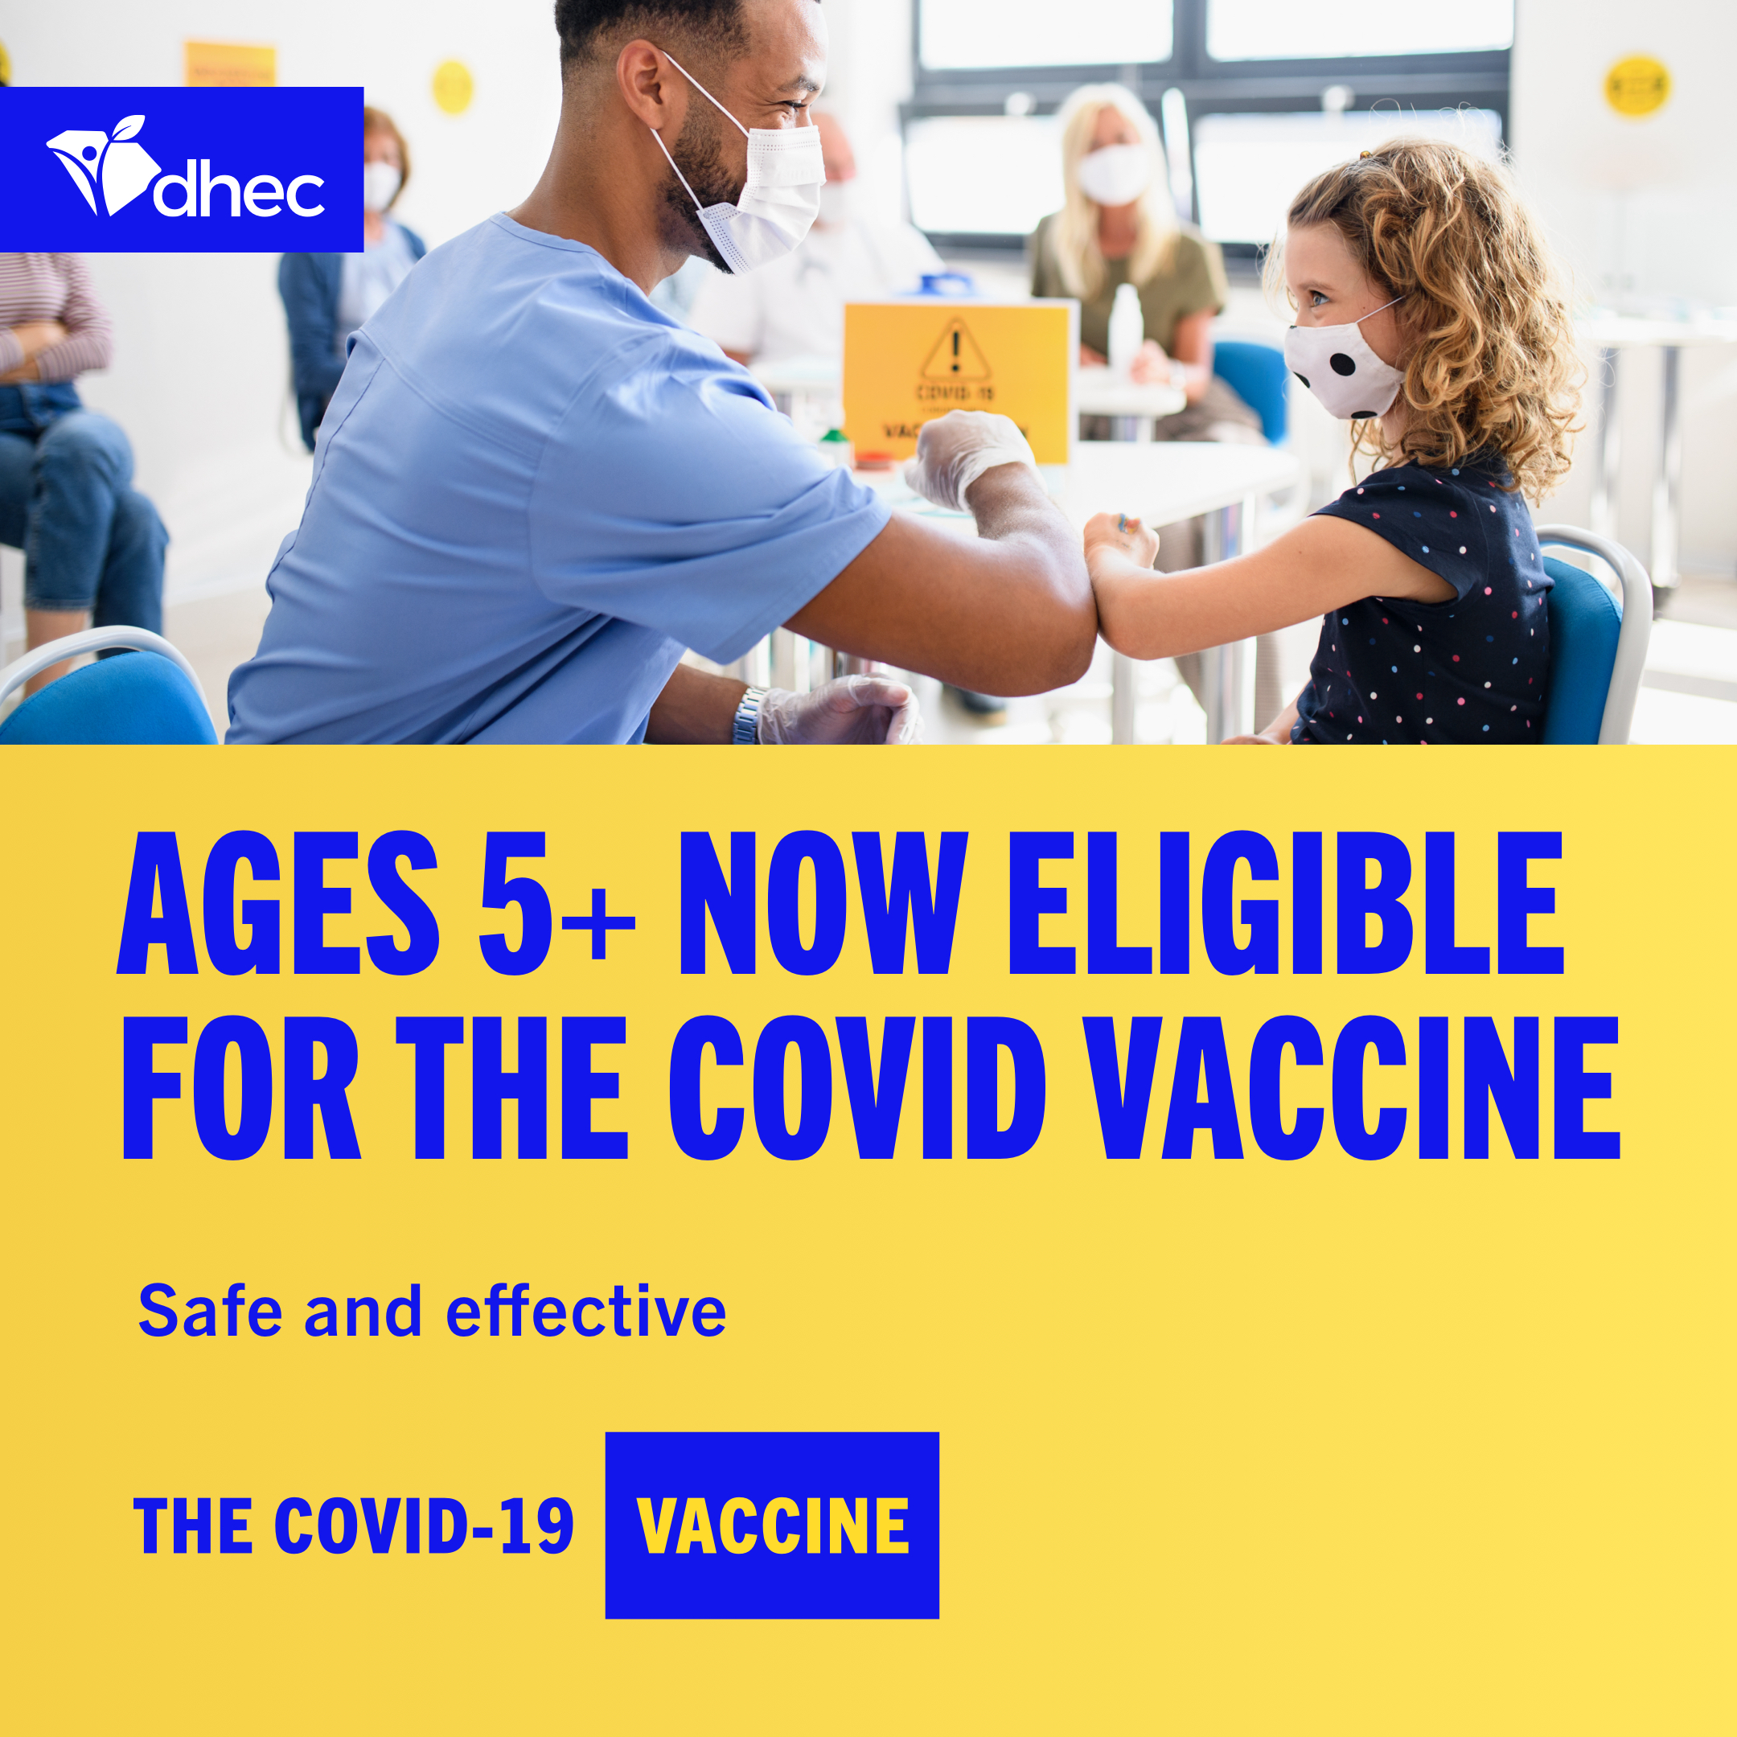
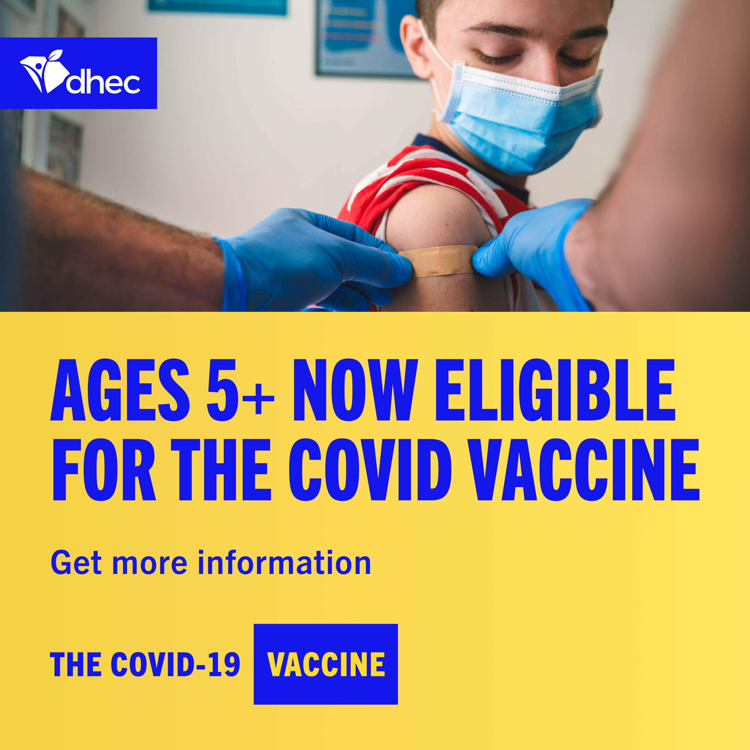

*Include the suggested image above or go to https://www.stayscstrong.com/community-toolkit to download a graphic or COVID-19 vaccine fact sheet to share along with your email.

