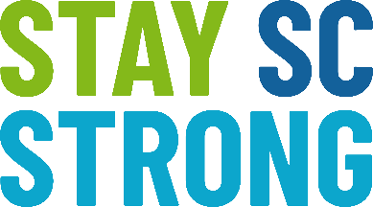 | South Carolina DHEC | Stay SC Strong Campaign  Email Content for Mask PSA
Wear a Mask When You Are Out in Public

COVID-19 can be transmitted quickly and easily—even by people who aren’t experiencing symptoms. If we’re going to Stay South Carolina Strong, we all have to do our part. Next time you go out of your home, for example to the grocery store, pharmacy, or some other space, be courteous to your neighbor: wear a mask.

A mask can help stop the spread of the virus—especially in places where physical distancing is difficult. And with new variants of COVID-19 spreading in our communities, people who’ve been fully vaccinated should continue to mask up in public in areas of high transmission, as well as getting a booster shot if you are eligible. Your mask should fit snugly and have at least two layers of material. For more guidance on how to Stay South Carolina Strong, visit the DHEC website at scdhec.gov/covid19

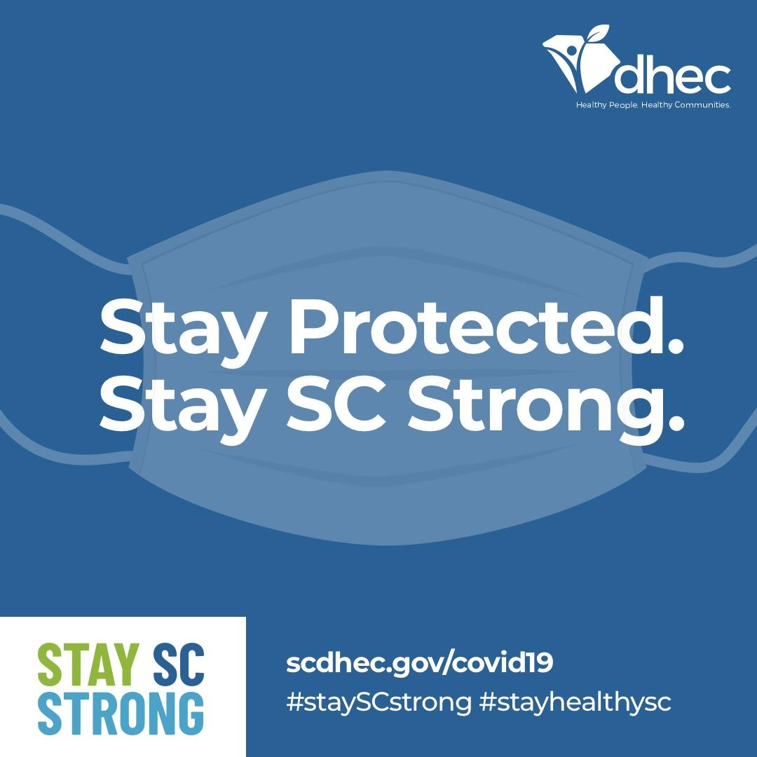

*this is a suggested image to include, please go to https://www.stayscstrong.com/mask-influencer-assets/ to download an image or graphic to use in the email

