Email Copy

Subject: Have you gotten your COVID-19 vaccine yet?

Body Copy:
South Carolinians age 5 and older can receive the safe, effective COVID-19 vaccine.

Protect yourself and those around you. Encourage folks in your community to get vaccinated as soon as possible.

- Visit scdhec.gov/vaxlocator to find vaccination locations near you.
- Need support? Call DHEC's Vaccine Information Line at 1-866-365-8110 for help.

Keep in mind, Pfizer is the only vaccine available to those aged 5+. All three vaccines—Pfizer, Moderna and Janssen—are available to those aged 18 and older.

Already vaccinated? While COVID vaccines are effective, their protection may decrease over time and as new variants emerge. If you’re 16+, see if you’re eligible for a booster shot.

Help us spread the word by sharing some of the social media posts below.

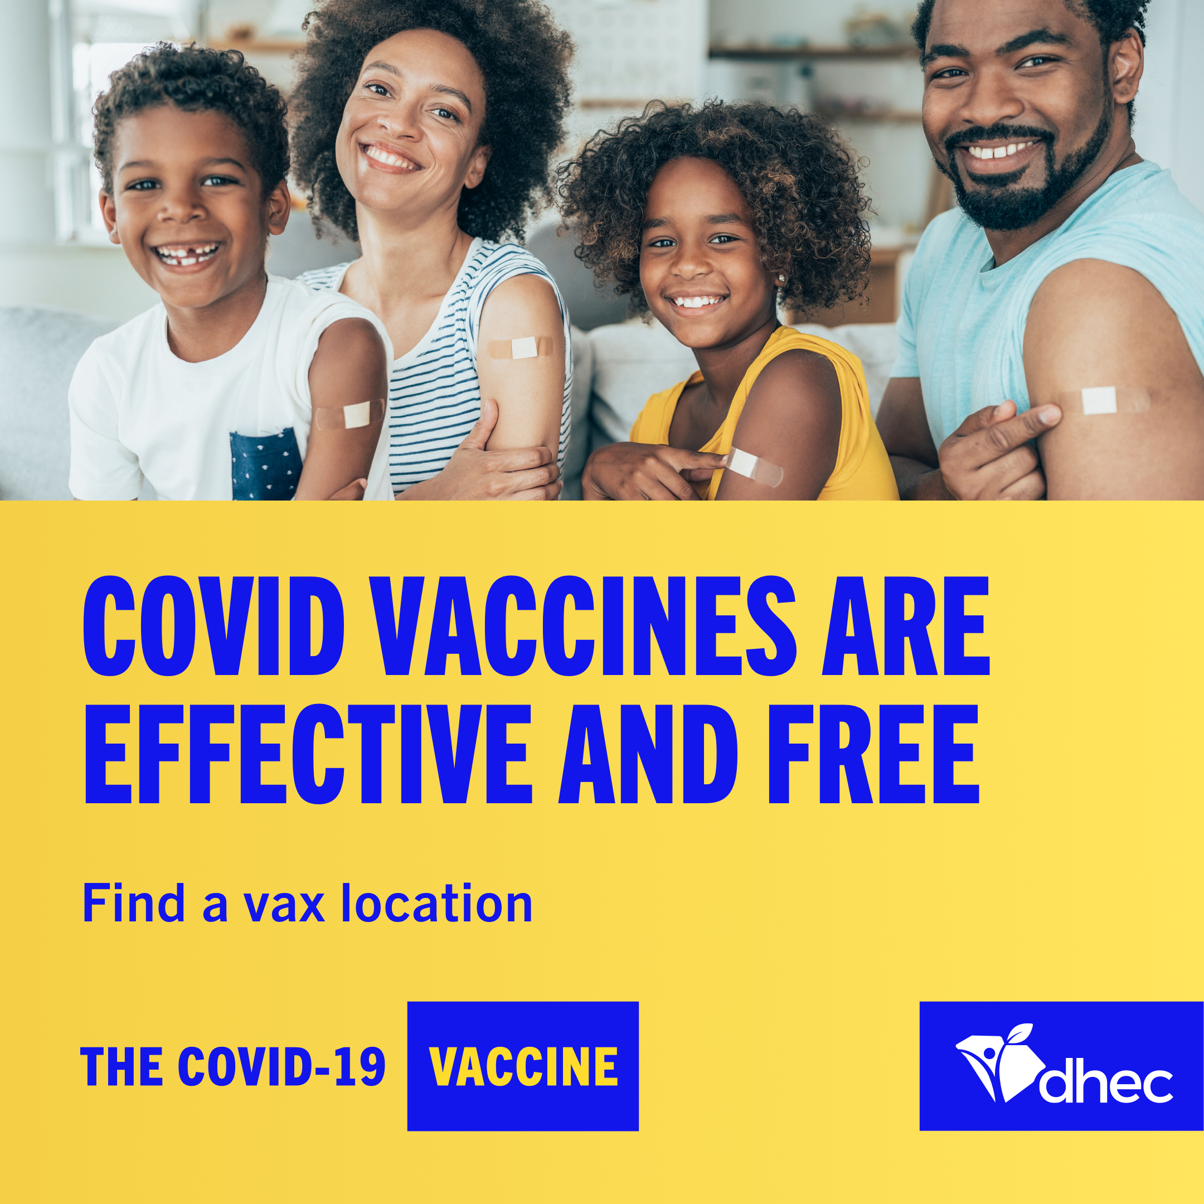

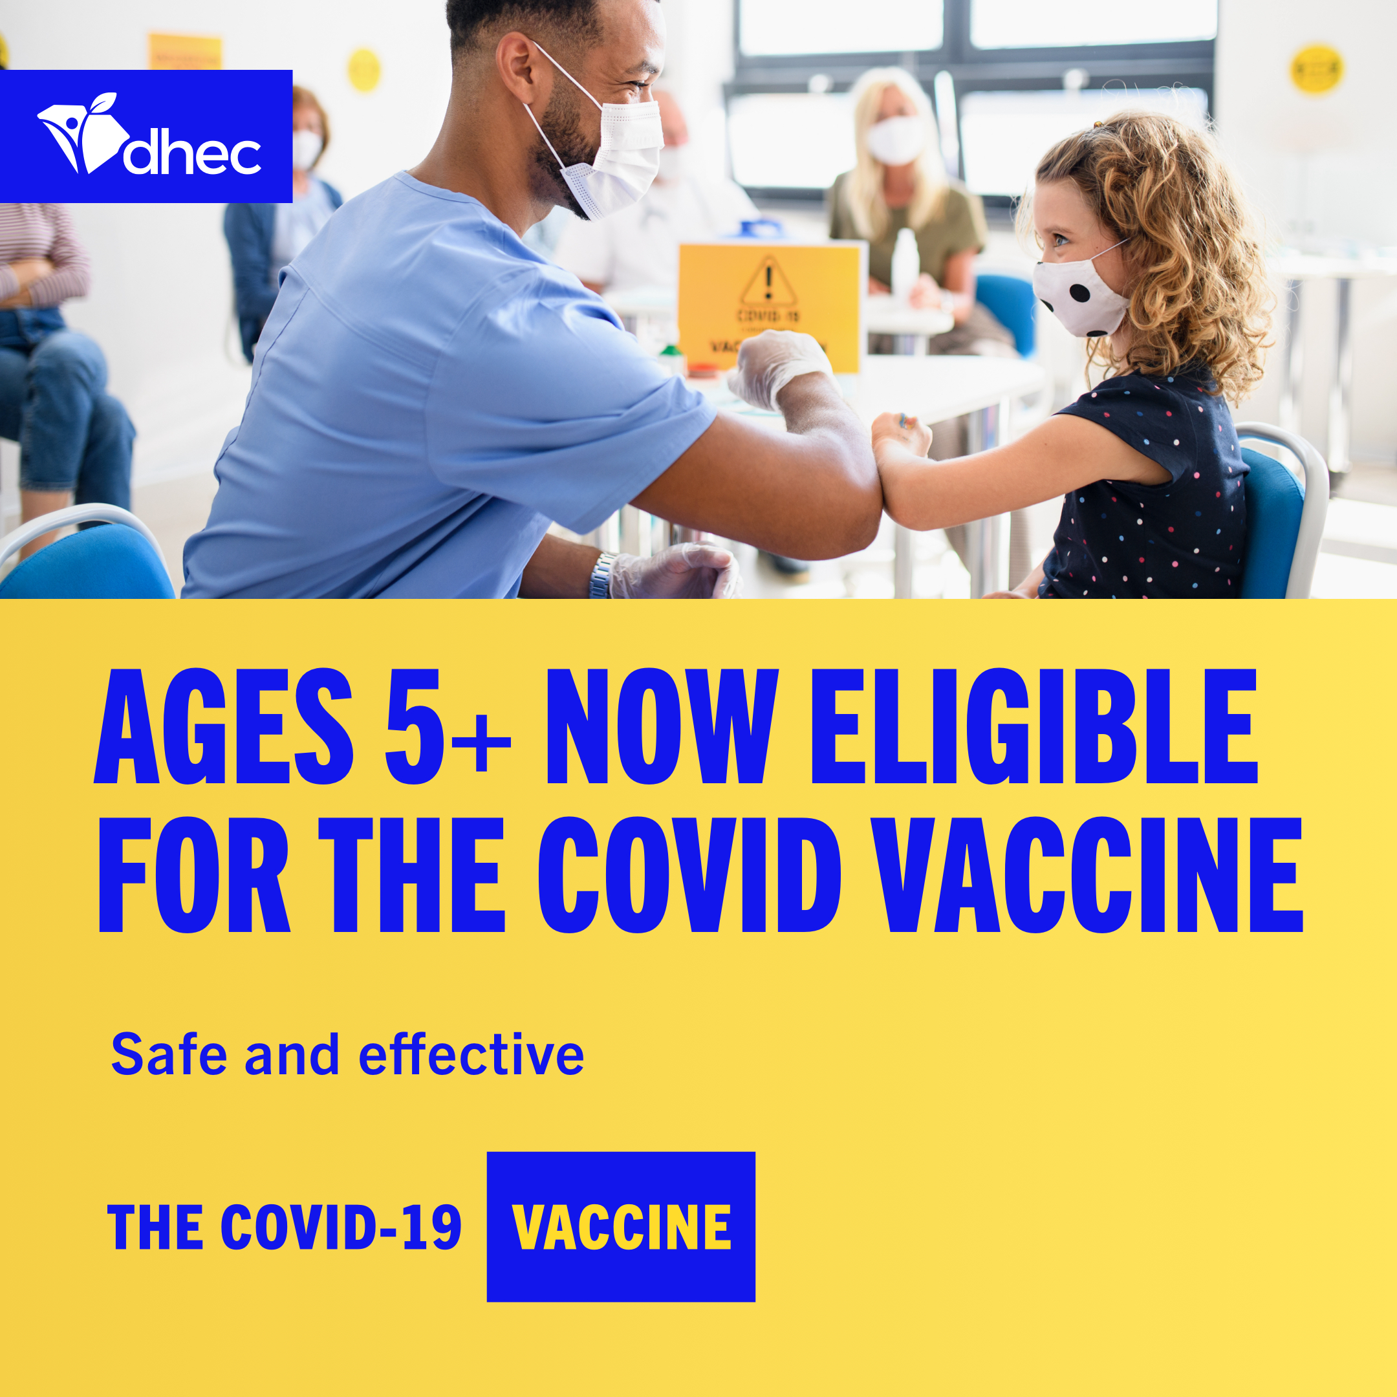

*Include the suggested image above or go to https://www.stayscstrong.com/community-toolkit to download a graphic or COVID-19 vaccine fact sheet to share along with your email.

